Module 1: An introduction to Chemical Engineering
This module introduces you to key chemical engineering concepts that will form the foundation for your chemical engineering education over the next several years. Learning these concepts, and how they relate to each other and chemical engineering in general will help you understand the field more fully and deeply.
Module 1 introduces different types of design seen in chemical engineering, key chemical engineering principles, and how chemical engineering relates to other fields. The module also introduces sustainable development and its relationship to chemical engineering.

Outline
Primary learning outcomes for the module:
- Develop an understanding of the different types of chemical engineering design and chemical engineering principles
- Develop an understanding of sustainable development and how it relates to chemical engineering
- Analyse real-world chemical engineering processes and identify types of design and chemical engineering principles
- Analyse real-world sustainable development issues and identify how chemical engineering can contribute to solving them

1.1 Introduction to Chemical Engineering

1.1.1 What is chemical engineering?
At its core, chemical engineering is about taking a raw material, transforming it through chemical, physical, and biological processes, and producing a product.
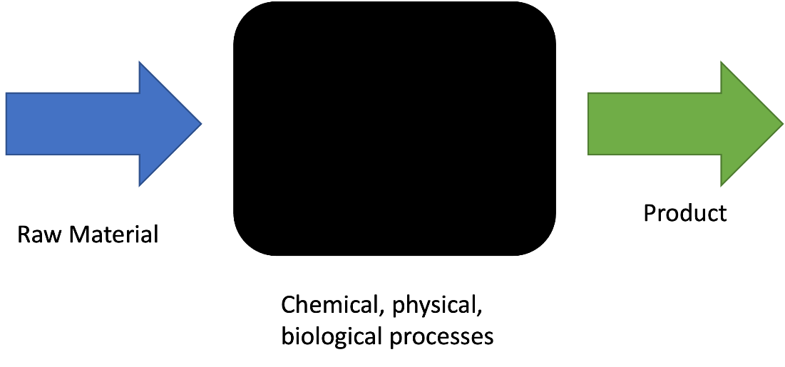

This basic chemical engineering recipe can take many forms; it includes a wide range of raw materials, lots of different processes (with new ones being invented all the time) and many different products, including waste streams. It can get complex quickly, with lots of moving parts. But we’ll break all these parts down and look at them individually over the course of this module.

Here are some examples of chemical engineering in action:
- Vaccine and pharmaceutical production
- Bioplastics in packaging
- Natural gas in your stove
- Biolipids produced by algae
- Water and wastewater treatment
- Mining and processing the metals in your smartphone
- Producing solar panels
- Remediating soil on a construction site
- Food production (from chocolate to meat-alternative burgers)

Chemical engineering is sort of like a “jack of all trades”; we use chemistry, physics, biology, mathematics, technology, and design to track and transform material and energy through complex systems with lots of moving parts.
There are also several sub-disciplines of chemical engineering. Process engineering is the application of chemical engineering principles on an industrial scale, and many chemical engineers become process engineers. Biochemical engineering is an emerging sub-discipline, focusing on the biological side of chemical engineering and is common in industries such as pharmaceuticals and food processing. Chemical engineers can move into other sub-disciplines, depending on their area of specialisation.

1.1.2 What does a chemical engineer do?
There are lots of different ways to be a chemical engineer, and not all people with a chemical engineering degree become chemical engineers (or chemical engineering lecturers). Because of the different skills picked up in chemical engineering degrees, they can do well in lots of different types of roles. In fact, CEOs of several big companies such as 3M, General Electric, and Dow Chemical are chemical engineers.
But here in this module, we’ll focus specifically on chemical engineers.
Chemical engineering work generally falls into two camps: working with new technology and working with existing technology. Engineers working with new technology can be designing a new process, creating a new product, processing a new raw material, processing a new kind of waste/ finding a use for a product previously considered “waste”. Engineers working with existing technology often focus on optimising existing process, products etc. based on new knowledge, new technology, or new regulations.
One of the big jobs of chemical engineers (and all engineers, to a degree) is design, and there are several “flavours” of design found in chemical engineering: process design, mechanical design, and control design.

- Process design: designing physical and chemical processes to turn raw material into products.
  - Based on chemical engineering concepts and principles (discussed below)
  - Includes factors such as calculating/ selecting the correct size, conditions (temperature, pressure, flow rate etc.) solvents, conversion etc.
- Control design: designing how chemical and physical processes will run efficiently and safely.
  - Based on process design.
  - Considers changes over time and plant operation.
  - Generally based on maintaining operating conditions for safe and efficient production.

- Mechanical design: designing physical unit operation/ piece of equipment that will perform chemical/ physical process.
  - Based on process design.
  - Considers material science and basic mechanical engineering principles.
  - Includes design factors such as equipment dimensions (height, length, width, diameter), any inlet and outlet pipes (including instrumentations requirements), and required safety features (wall thickness for pressure rating, pressure relief valves etc.)

Worked Example 1.1 Chemical Engineering Design
Ethanol is an important feedstock chemical in many industries, from fuel production (e.g., E-10 petrol) to medicine (e.g., sanitizing work surfaces). One example everyday example of ethanol is hand sanitizer: ethanol at 65% or above will disrupt cell membranes and denature proteins of bacteria and viruses (although not all micro-organisms).
Ethanol can be produced from several sources but is mostly produced by yeast via fermentation. The yeast can only produce ethanol to approximately 12% (above this concentration, it acts as a toxin and harms/kills the yeasts). Because of this, the ethanol needs to be purified before it can be used in hand sanitiser: we need to separate the ethanol from the water in the solution in a process called “distillation”. (Distillation is a very important unit operation in chemical engineering, and you will learn more about it in later subjects).
Distillation is based on volatility (how much the component wants to turn into a vapour) of the different components (ethanol and water) at different temperatures. Ethanol is more volatile than water, so it will turn into a vapour at a lower temperature. A distillation tower is built, then heated and pressurised to a certain temperature and pressure that allows the ethanol to boil off (turn into a vapour and exit the tower at the top) but keeps the water liquid (so it runs down to the bottom of the tower). (The real process is much more complicated, but this is a simplified version for the worked example).
Based on the above information, briefly describe the process design, control design, and mechanical design decisions made to distil an ethanol-water mixture into ethanol that can be used in hand sanitiser.

Process Design:

Control Design:

Mechanical Design:

Engineering as a field cannot function with teamwork. Chemical engineers work with each other to design a whole process, from material to product. They also work with other engineering disciplines as chemical engineers cannot know everything. Chemical engineers bring their knowledge to the table and work with other specialists’ knowledge to come up with the best solution to that particular problem. Chemical engineers will also work with lots of other people like managers, executives, scientists, regulators, operators, consumers and almost every kind of stakeholder imaginable. While some chemical engineers may work alone much of the time, no job in chemical engineering takes place in a vacuum (although maybe in a vacuum pump…), they are always working with other people.
Some chemical engineers will be inside all day working on simulations and excel spreadsheets. Some will be in a lab creating and playing with new technologies. Some will be out on site/ on a plant seeing how big pieces of technology operate. Some will be doing a combination of all sorts of jobs.
There are lots of different ways of working in chemical engineering and using your chemical engineering knowledge: there is no “one perfect way” to be a chemical engineer.

1.1.3 What principles and concepts does chemical engineering use?
We use a wide variety of principles and concepts in chemical engineering, because we work in many different industries and across many different scientific disciplines. We won’t discuss these in much detail, but we will discuss how they relate to chemical engineering problems.

Material and Energy Balances: one of the key parts of chemical engineering. Chemical engineers track material and energy, and how they transform, through complex systems. Material and energy cannot be created or destroyed, so we account for everything that comes into and out of our systems. It’s like complex accounting, but things can explode if we count wrong, so it’s a bit more exciting than normal accounting.
- You’ll learn this in Material and Energy Balances and will use it throughout your chemical engineering education.
Systems Thinking: all engineers use system thinking, but it is especially important in chemical engineering. Chemical engineers think in terms of whole systems and how they operate, not only focusing on specific parts of a system.
- You’ll learn this throughout your chemical engineering education.
Unit Operations: all systems are made up of individual pieces, and chemical engineering processes are made up of unit operations.
- You’ll learn basic unit operations in Fundamentals of Chemical Engineering and Material and Energy Balances, and learn more advanced unit operations as you move through the degree.
Thermodynamics: the study of energy use and transformation, thermodynamics looks at how we can harness and manipulate energy
- You’ll learn basic thermodynamics in Module 4 and more advanced thermodynamics in Chemical Engineering Thermodynamics.

Reaction Kinetics: this puts the “chemical” in “chemical engineering”. Reaction kinetics looks at controlling chemical reactions to efficiently produce the products we need.
- You’ll learn basic reaction kinetics in Module 5, and advanced reaction kinetics in Reactors and Catalysis and Chemical Engineering Thermodynamics.
Transport Phenomena: the control momentum, heat, and mass as they move through a piece of equipment and through a system.
- You’ll learn about heat transport in Module 4 and learn more advanced content on transport phenomena in Momentum, Mass, and Heat Transfer, and Thermal and Separation Design.
Separation Processes: chemical engineers never deal with pure substances – everything is a mixture. These mixtures need to be separated so raw materials, products, and other streams contain the right components.
- You’ll learn separation processes throughout your chemical engineering education.

Fluid Mechanics: chemical engineers work with water, air, and many other kinds of fluids. Understanding how fluids behave allows engineers to control them and their processes effectively and safely.
- You’ll learn about fluid mechanics in Fluid Mechanics, Momentum, Mass and Heat Transfer and Thermal and Separation Design.

Safety: chemical engineers need to make sure all our processes operate safely, protecting people and the environment
- You’ll learn about safety throughout your chemical engineering education

Control: chemical engineers need to control processes to make sure they’re safe, efficient, and producing the required products.
- You’ll learn the basic of control in Module 3 and advance this knowledge throughout your chemical engineering education.

Worked Example 1.2
Let’s look at a simplified version of a real chemical engineering situation in the pharmaceutical industry. Some pharmacological compounds are built through organic chemistry, and some needed to be extracted from natural sources, often plants. A common example of this is extracting opiate compounds from poppies. In this (simplified) example, chemical engineers take the raw material of poppies, crush them, add a solvent, and heat the solution. The solvent and heat dissolve the opiate compounds in the poppies, and a few other unwanted compounds. The fluid, made up of solvent and dissolved compounds, is sent to a crystalliser. The fluid is then cooled to a specific temperature, which lets the opiate compounds crystalise out of solution while the unwanted compounds and solvent remain in the liquid phase. The crystals (solids) are sent to further refining. The solvent with unwanted compounds and the exhausted poppies are sent to waste treatment. These processes take place at ambient temperature and pressure (no significant increases or decreases compared to 25°C and 101 kPa) and only physical transformation (phase change) occurs.

From this example, identify and explain the chemical engineering principles used. From this list, identify the decisions made in the process design, control design, and mechanical design stages.

Principles:

Process Design:

Control Design:

Mechanical Design:

1.1.4 How is chemical engineering different from chemistry and other engineering disciplines?
There is a lot of crossover between chemical engineering and chemistry as well as chemical engineering and other engineering disciplines. This doesn’t mean that chemical engineering isn’t unique; instead, it means that chemical engineers can talk to and understand other kinds of science and engineering specialists.
Chemists generally look at chemistry on a small scale. For example, a chemist might work out how to extract a pharmaceutical from a plant source like poppies. But a chemical engineer looks at how to get that pharmaceutical from poppies on a large scale, including factors like product purity, waste processing, energy efficiency etc., much more than the chemical steps from the plant chemical to the extracted chemical.
Chemical engineers think in a similar way to many other engineers, but we see everything through a chemical engineering lens. For example: water. Chemical engineers see water as a solvent, solution, mixture, and a fluid with physical and chemical properties. Civil engineers see water as a fluid to be controlled over large distances. A similar analogy can be applied to mechanical design for mechanical engineers, model development to software engineers, and material properties to material engineers.
This means that chemical engineers can understand what happens in lots of engineering contexts, and can even translate between scientific and engineering disciplines, which is pretty powerful!

1.1.5 Why is chemical engineering important?
Society doesn’t run without engineers, and that includes chemical engineers. The roles that chemical engineering fills can be split into three broad categories: past, present, and future.
Previous generations of chemical engineers have left a legacy: unfortunately, it is a legacy to fix. It is the current and future generation of chemical engineers’ responsibility to deal with pollution in various environments and the effects of this pollution (e.g., climate change, habitat degradation)
Our present-day society needs goods and services that engineering, specifically chemical engineering, provides such as clean water, food, energy, Doritos, fancy face washes, vaccines etc.
Chemical engineers are contributing to and will continue to contribute to the future as well: designing new technologies, solving new problems we haven’t seen yet, working with digital technology, creating a more equitable world and more.
The list of chemical engineering contributions to the world, and thus the reasons why chemical engineering is important, is wide reaching and ever-growing.
And we need chemical engineers now, in Australia, more than ever. There is a significant engineering shortage in Australia: many of the country’s engineers are imported. This shortage has been increased by international border closures as well. Graduate employment for chemical engineers remains high. Studying chemical engineering will set you up well for your future and the world’s future.

1.2 Sustainable Development
We know that there are a lot of problems in the world at the moment, on a global and local scale. This section will look at how chemical engineering can contribute to solving these problems.
We’ll look at one such problem in detail as a case study on chemical engineering and sustainable development: pollution.

The first step of this case study is acknowledging that pollution is a complicated topic that affects billions of people around the world. There is no one perfect solution to this problem. But instead of feeling disheartened by this, we can choose to look at pollution through the lens of sustainable development and come up with a plan to contribute to fixing it. Chemical engineering cannot solve this problem on its own, but that’s okay. Sustainable development is about working together and contributing to a solution with other parties.

1.2.1 What is Sustainable Development?
Sustainable Development (SD) can be defined in several ways. One of the most common definitions is “development that meets the needs of the current generation without compromising the ability of future generations to meet their own needs”. This definition entered Western discussion in the late 1980s (but has been around for much longer than that in many societies around the world).
We can also look at the different dimensions, or pillars, of SD: environmental, economic, and social. (There are other pillars that get used, but we will focus on these three). Let’s look at our case study of pollution through the lenses of the different pillars.
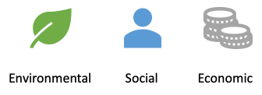

- Environmental: different types of pollutants impact different natural habitats such as acid rain in the atmosphere (and land/ water when it rains), hydrocarbons in soil and groundwater, textile pollution in freshwater, and sewage pollution in fresh water and the ocean. These pollutants often impact animal and plant life in the area as well, stressing and damaging the ecosystem.
- Economic: depending on regulation, it is often cheaper to dump pollutants than treating them to a safe standard. This gives pollution an economic advantage compared to waste treatment. However, valuable chemicals are wasted if process streams are left un-treated: those valuable chemicals cannot be recovered if there is no waste treatment. The true economic cost of pollution, such as the loss of productive soil and impact on healthcare costs, are often omitted from cost estimate and thus do not show the true economic impact of not treating pollution.
- Social: pollution can lead to a range of poorer outcomes for the impacted community. Minority populations are more likely to be impacted due to existing economic and social factors. Pollution often leads to worse health outcomes for those living in the area (e.g., respiratory conditions from particulate pollution), including both acute and chronic conditions. This often reduces educational and economic opportunities for the community, further lowering quality of life.

All three pillars are important: there’s no one dominant pillar. Their importance can shift depending on the situation and context, but they are always linked together.

1.2.2 Sustainability vs. Sustainable Development
Even if you haven’t heard about sustainable development before now, you’ve very likely heard the term “sustainability”, but what’s the difference between the two? Is there a difference?
Well, it depends on the definition that people are using. Some people use the two terms interchangeably, but they’re not the same thing. A definition I like is that sustainable development is the road towards sustainability: sustainable development is a tool and sustainability is the end goal.
Many people also use sustainability only when referring to the environment i.e., environmental sustainability. But the other pillars are important as well, so using “sustainable development” clarifies that we are referring to all the pillars.

1.2.3 Sustainable Development Goals
The United Nations developed the Sustainable Development Goals (SDGs) in 2015: a set of 17 goals to guide global development to 2030. They replaced the Millennial Development Goals produced in 2000. The SDGs are not a complete set of goals but represent a compromise on the important issues to all the signatory countries. The SDGs are a useful tool when considering the impacts of different projects and different actions. The topics of the 17 goals can be seen in the diagram below and lay across all 3 pillars.

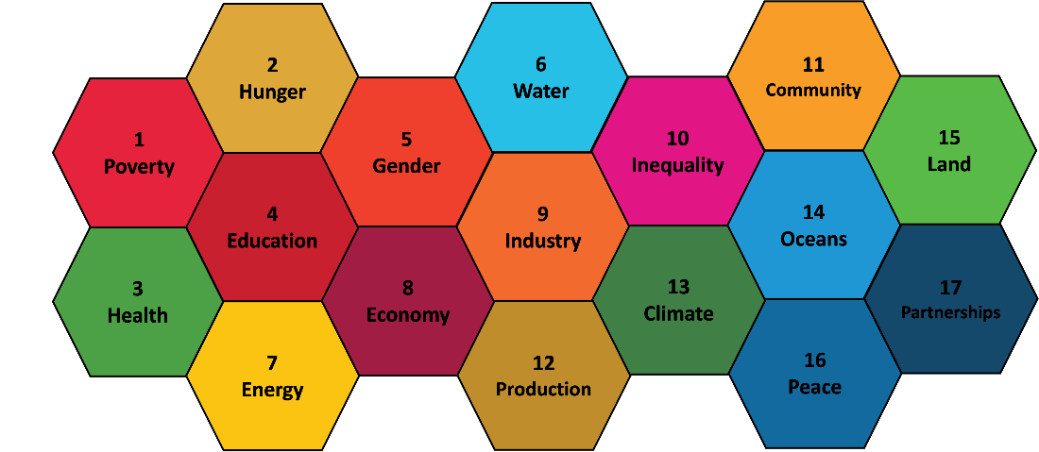

It’s important to keep in mind while we’re learning all this that sustainable development is more than the sum of its parts. Sustainable Development is a holistic paradigm, looking at transforming the world as a whole, not focusing on discrete areas.

1.2.4 How can chemical engineering contribute to sustainable development?
There are lots of different ways chemical engineering can contribute to sustainable development. If we look at the SDGs, for example, we can see that chemical engineering can easily contribute to a number of the goals. The diagram below shows some examples, such as soil remediation helping Goal 15 (Life on Land) and fertiliser production helping Goal 2 (End World Hunger).
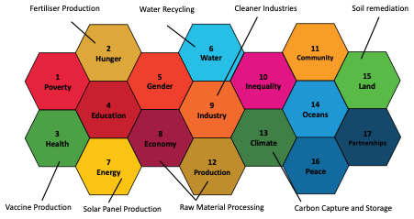

But we can look at these issue more deeply through our pollution case study. How can chemical engineering contribute to solving pollution?
There are many different sources of pollution, and we’ll need a different strategy for each source. We’ll begin with sulfur from natural gas causing acid rain:
To look at this issue systematically (using our “systems thinking” principle), we can look at removing the source of pollution, changing how the waste/ pollution is processed, how to mitigate the existing effects of the pollution.
- Removing the source: using renewable energy such as solar, wind, hydro instead of natural gas (coal and other fossil fuels often also have sulfur in them when extracted from the ground) would mean sulfur wouldn’t need to be removed.
- Changing how the waste is processed: Separate out the sulfur from the natural gas and treat it so it doesn’t escape into the atmosphere (in this example, it would likely be a “wet scrubber” which basically dissolves the sulfur in water droplets in a shower, so only air escapes).
- Mitigating the effects: produce acid-resistant coatings for exposed infrastructure, remediating the soil to balance the pH

Worked Example 1.3
Explain how chemical engineering can contribute to solving the issue of textile processing wastes in local water sources, including removing the source of pollution, changing how the waste is processed, and mitigating the effects. Textile waste is a mixture of dyes, fasteners and a range of other chemicals, often with pH values far away from neutral (either acid or basic). These mixtures can also have high salt and particulate loads, and may also contain heavy metals.

- Removing the source:
- Removing the source:
- Changing how the waste is processed:
- Mitigating the effects:
- Mitigating the effects:
- Mitigating the effects:

There are many other ways to solve this problem, but we are looking specifically at what chemical engineering can do.

Module 1 Summary

Key Points:
- What chemical engineering is
- What chemical engineers do
- Chemical engineering principles and concepts
- Difference between chemical engineering, chemistry, and other engineering disciplines
- Why chemical engineering is important
- What is sustainable development
- How chemical engineering contributes to sustainable development

Key Skills:
- Identifying chemical engineering principles and concepts
- Identifying process, control, and mechanical design decisions
- Identifying how chemical engineering contributes to sustainable development

